**Experiment 1**

**Student Name:** Vedant **UID:** 22BCS10618 **Branch:** BE-CSE **Section/Group:** 22BCS_IOT_603A **Semester:** 6th **Date of Performance:** 08-01-25

**Subject Name:** AP Lab-2 **Subject Code:** 22CSP-351

1. **Aim:** Full Stack Development (MERN).

The primary aim of this experiment is to provide students or developers with an understanding

of full-stack development involving MongoDB, Node.js, React, and Express.

Problem 1.1.1: Give understanding of MongoDB, Nodejs, React, Express.

Problem 1.1.2: Create a Frontend design of Login/Signup pages and create a backend of it.

Problem Breakdown.

Problem 1.1.3: Test the Backend API Using Postman.

# Objective:

1. Learn about MongoDB: Understand how to use MongoDB as a NoSQL database for storing and retrieving user data.
2. Learn about Node.js: Understand how to set up and use Node.js as a backend server and handle API requests.
3. Learn about Express.js: Understand how to use Express.js to create routes and handle HTTP requests in the Node.js server.
4. Learn about React: Learn how to create a simple frontend interface with React to handle user interactions (login/signup).
5. Backend API Testing: Use tools like Postman to test backend APIs and ensure the server is responding correctly.
6. Integration: Integrate the frontend (React) with the backend API to create a full-stack authentication system.

# Implementation/Code:

import React, { useState } from 'react'; import axios from 'axios';

const Login = () => {

const [email, setEmail] = useState('');

const [password, setPassword] = useState(''); const [message, setMessage] = useState('');

const handleSubmit = async (e) => { e.preventDefault();

try {

// Send login request to the server

const response = await axios.post('[http://localhost:5000/api/auth/login',](http://localhost:5000/api/auth/login%27) { email,

password,

});

// Update message and save the token setMessage(response.data.message);

localStorage.setItem('token', response.data.token); // Store JWT token

} catch (error) {

// Show error message if login fails setMessage(error.response?.data?.message || 'Login failed');

}

};

return (

<div style={{ maxWidth: '400px', margin: 'auto', padding: '20px' }}>

<h2>Login</h2>

<form onSubmit={handleSubmit}>

<div>

<label>Email</label>

<input type="email" value={email}

onChange={(e) => setEmail(e.target.value)} required

/>

</div>

<div>

<label>Password</label>

<input

type="password" value={password}

onChange={(e) => setPassword(e.target.value)} required

/>

</div>

<button type="submit">Login</button>

</form>

{message && <p>{message}</p>}

</div>

);

};

export default Login;

# Output

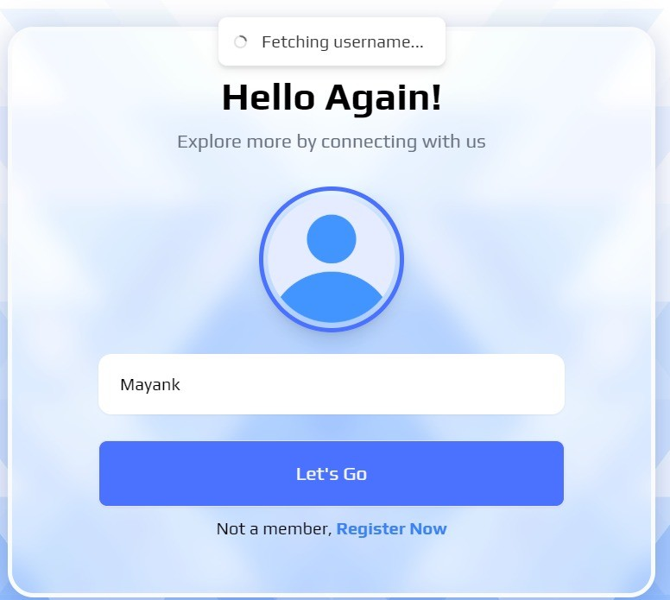

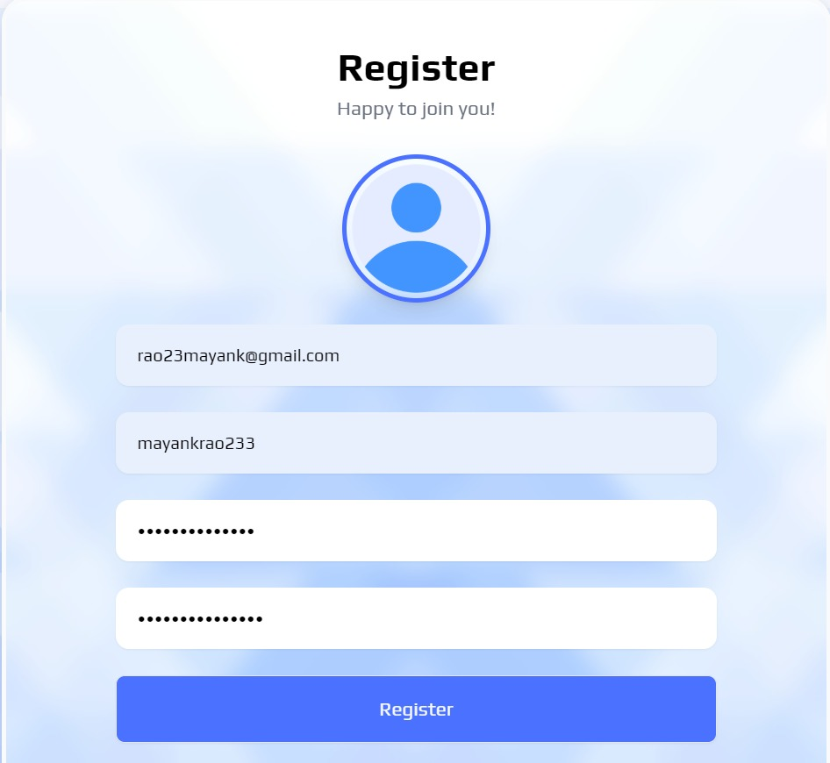

1. **Learning Outcome:**
   1. We Learn About the use of React.
   2. We Learn About the use of Express.
   3. We Learn About the use of MongoDB.
   4. We learn About the Connection.
   5. We Learn About the Calling For the Username and password.